Supplementary file

Chemical characterization and anti-inflammatory activity of phytoconstituents from Swertia alata
SAKSHI BAJAJ ^{1*}, SHARAD WAKODE ², NEERAJ FULORIA ³, SHIVKANYA FULORIA ^{3,} AVNEET KAUR ²
Spectrum 1: ¹HNMR spectrum of SA4

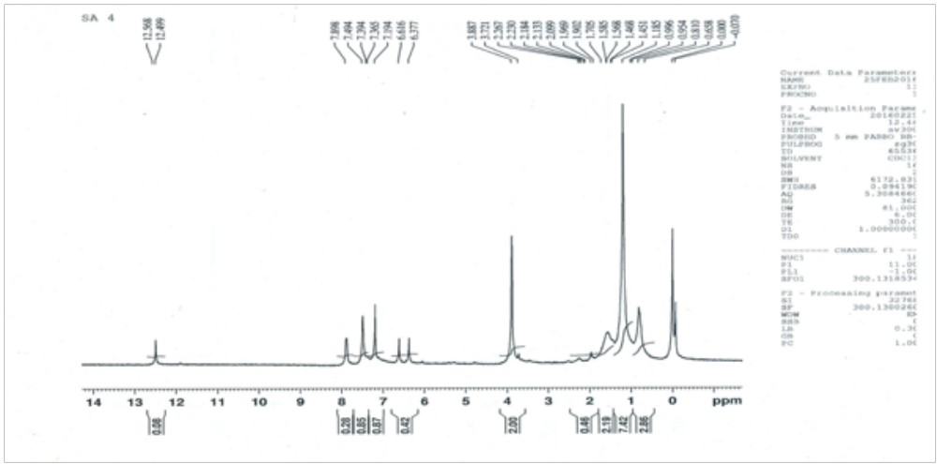
Spectrum 2: ¹³CNMR Spectrum of SA4
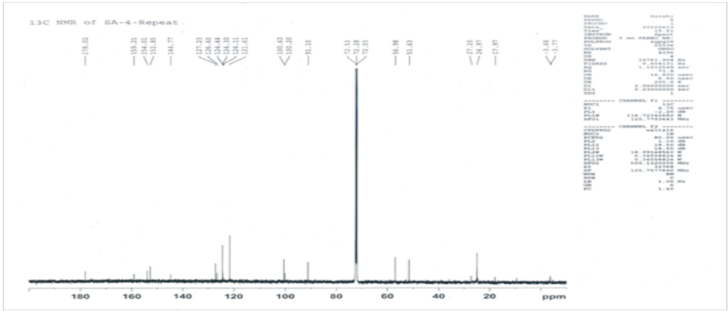

Spectrum 3: IR spectrum of SA4
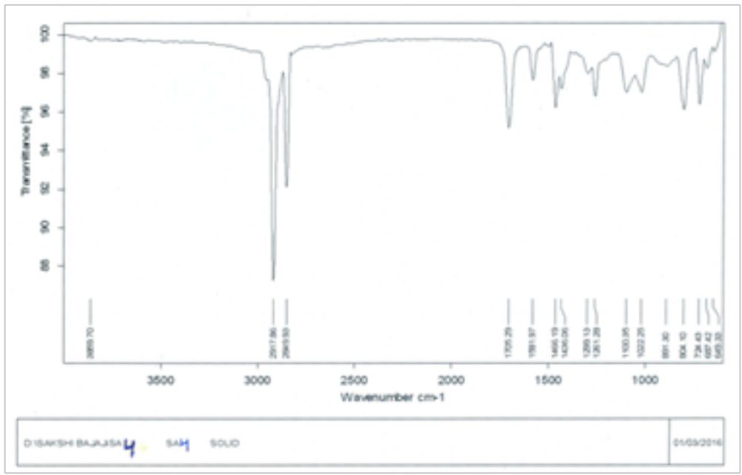

Spectrum 4: Mass spectrum of SA4

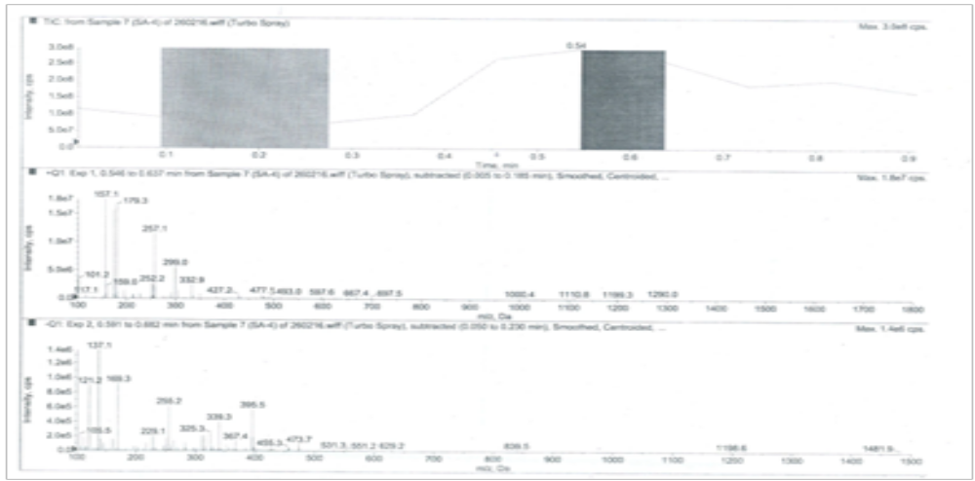
Figure S1- Spectras of SA-4
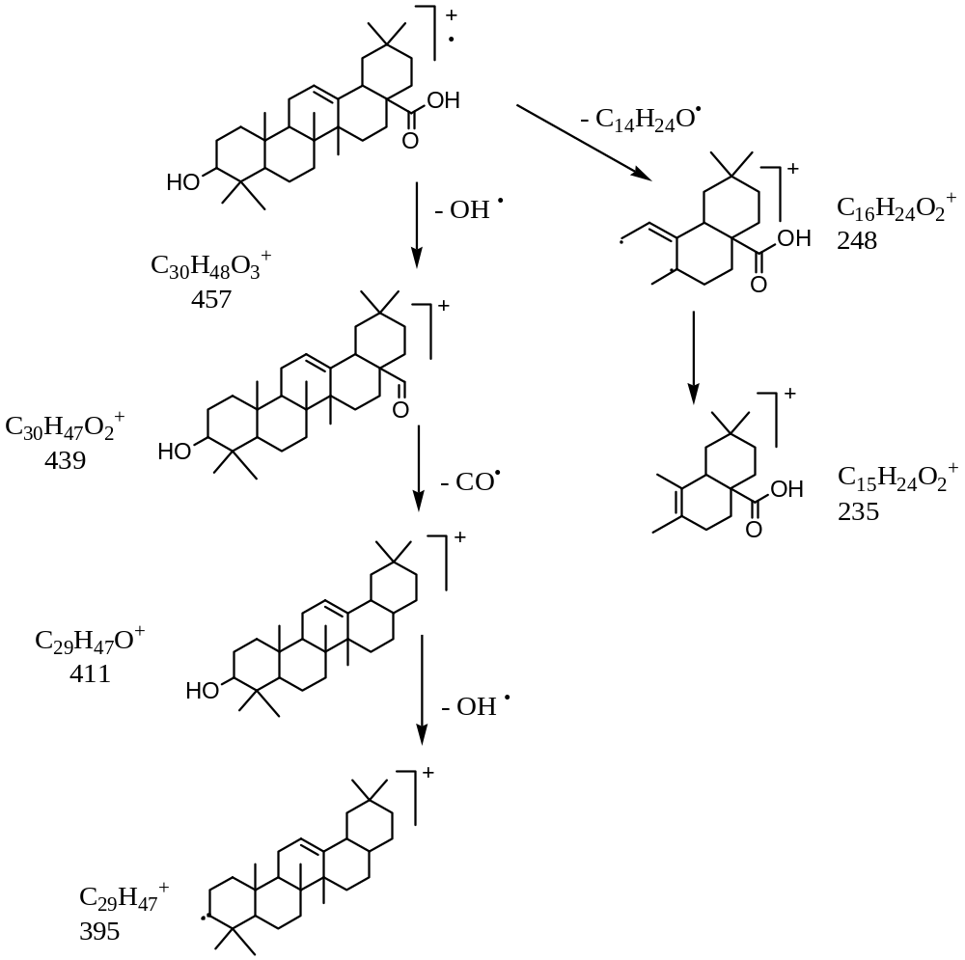

Supplementary Scheme S2: Mass fragmentation pattern of Oleanolic acid (SA-1)

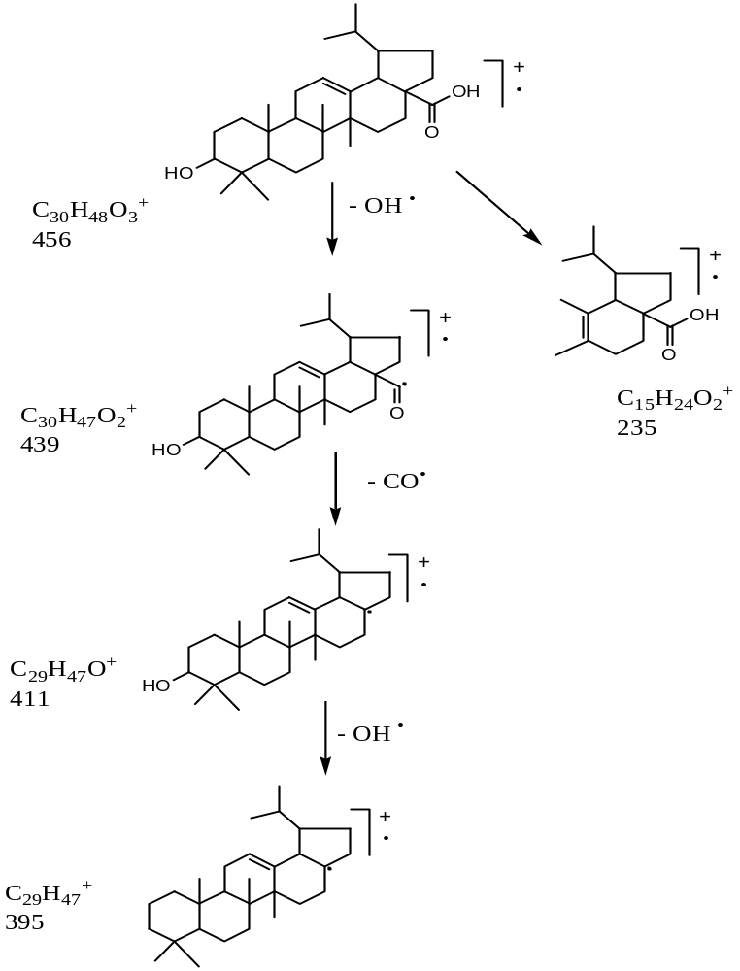

Supplementary Scheme 3: Mass fragmentation pattern of 3-Hydroxylup-12-(13)-ene-17-carboxylic acid (SA-4)

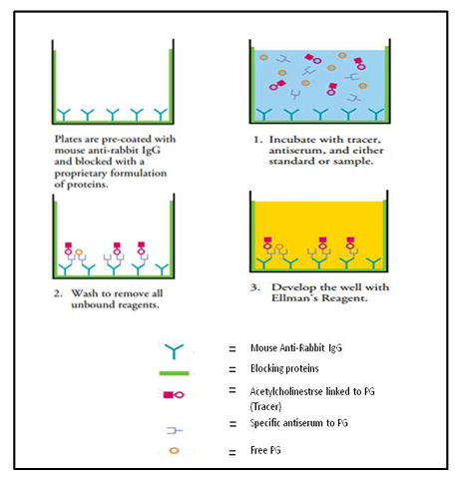

Supplementary Figure S4: Principle of in vitro enzymatic assay kit (Catalogue no. 560131)

Supplementary Figure S5: Macroscopic observation of gastric mucosal lesions in ulcer model a) Indomethacin (21 mg/kg) b) Control c) SA-4(12mg/Kg) d) SA-4 (24mg/kg) e) SA-1 (24mg/Kg)

